Objectives:

* Creating multiple scenes using ONE class
* Connecting to databases

**There are 3 print screens/code copies each worth 33.3%**

**Example #1**

Creating the login GUI using JavaFX

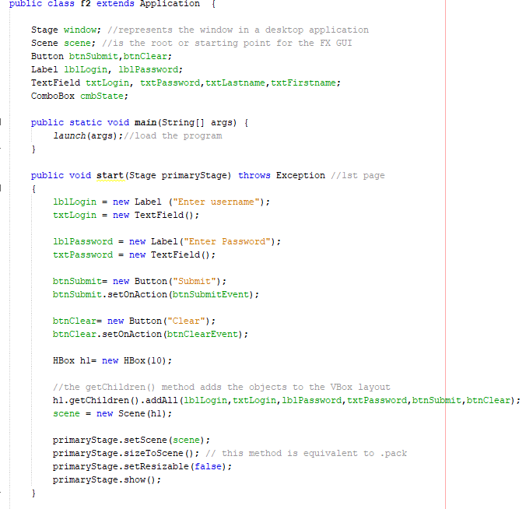

1st scene

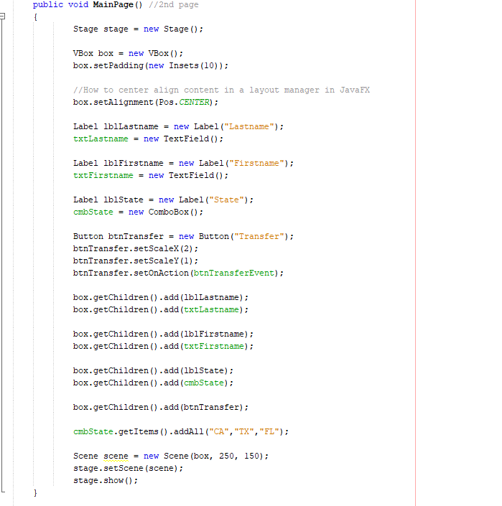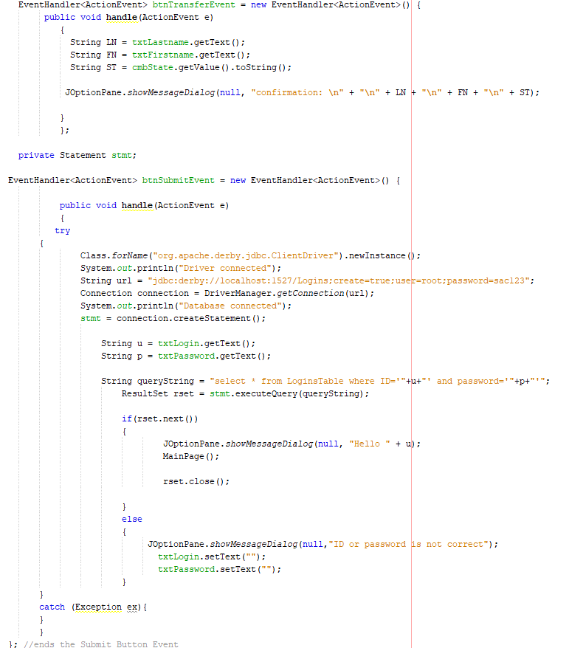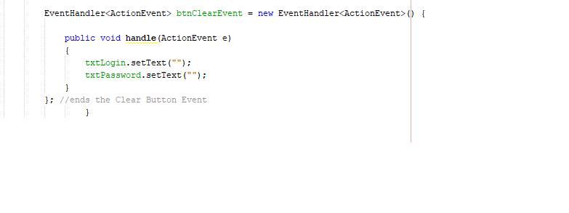

The 2nd scene

This is where the 2nd page starts

Calling the 2nd page

Derby Database >> **Java** **DB**

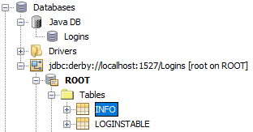

Table Design for **LoginsTable**



Table Design for **Info**



**Example #2 (see next page)**

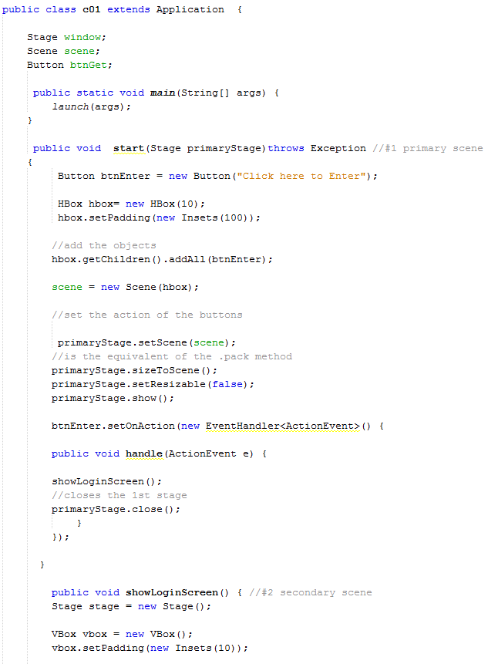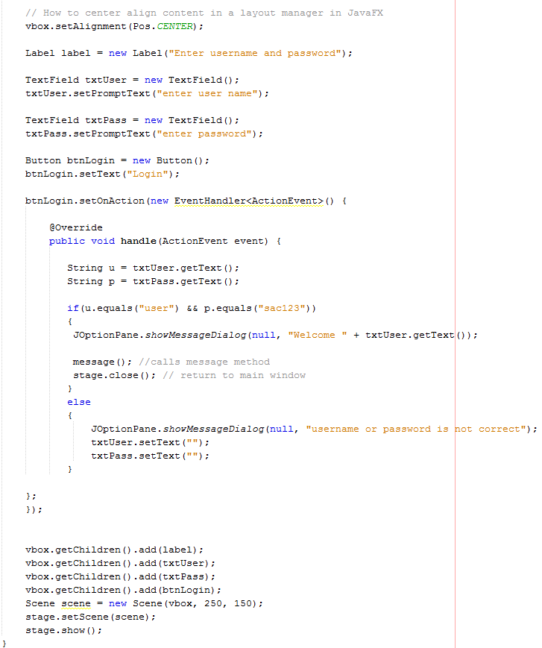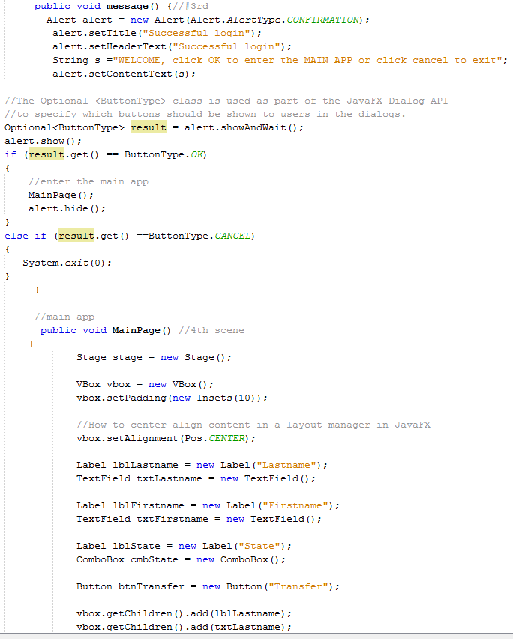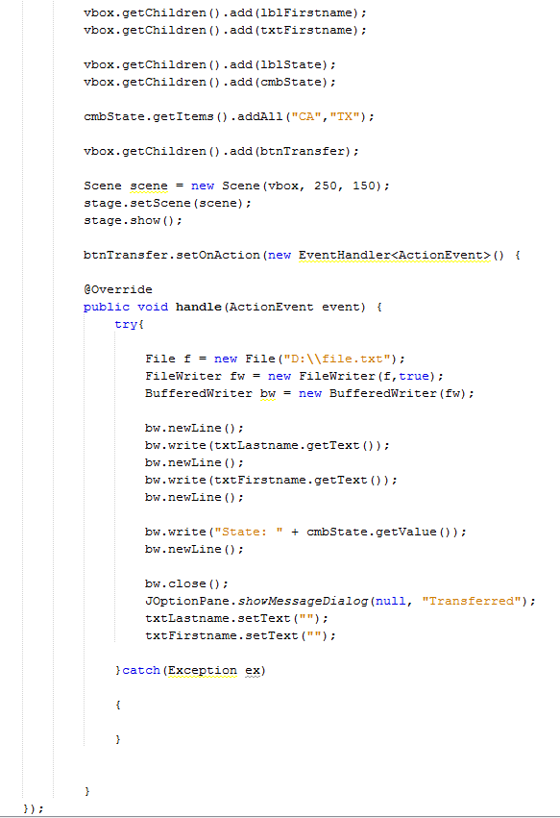

**Challenge Exercise**

Pass the following JavaFX app to the derby database/table. When the user types in the Last and First names with state and clicks on the Transfer button, transfer the data into a table.

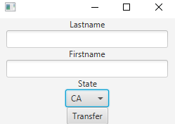

**#1 print screen the confirmation that the data has been transferred below here**

**#2 print screen the table below here with the new data**

**#3 copy and paste the code below here**

**Submit this document to module 09 Class Exercise #7**